DAD-220
Professor Gupta
Byron Laferriere
10 May 2020

1. Access MySQL through Codio terminal using command line prompt:
- sudo mysql -u root -p
  - press enter
  - enter root password

- Create new database and update the name to my Last name, then access it using the commands:
  - create database Laferriere;
    - press enter
  - show databases;
    - press enter
  - use Laferriere;
    - press enter
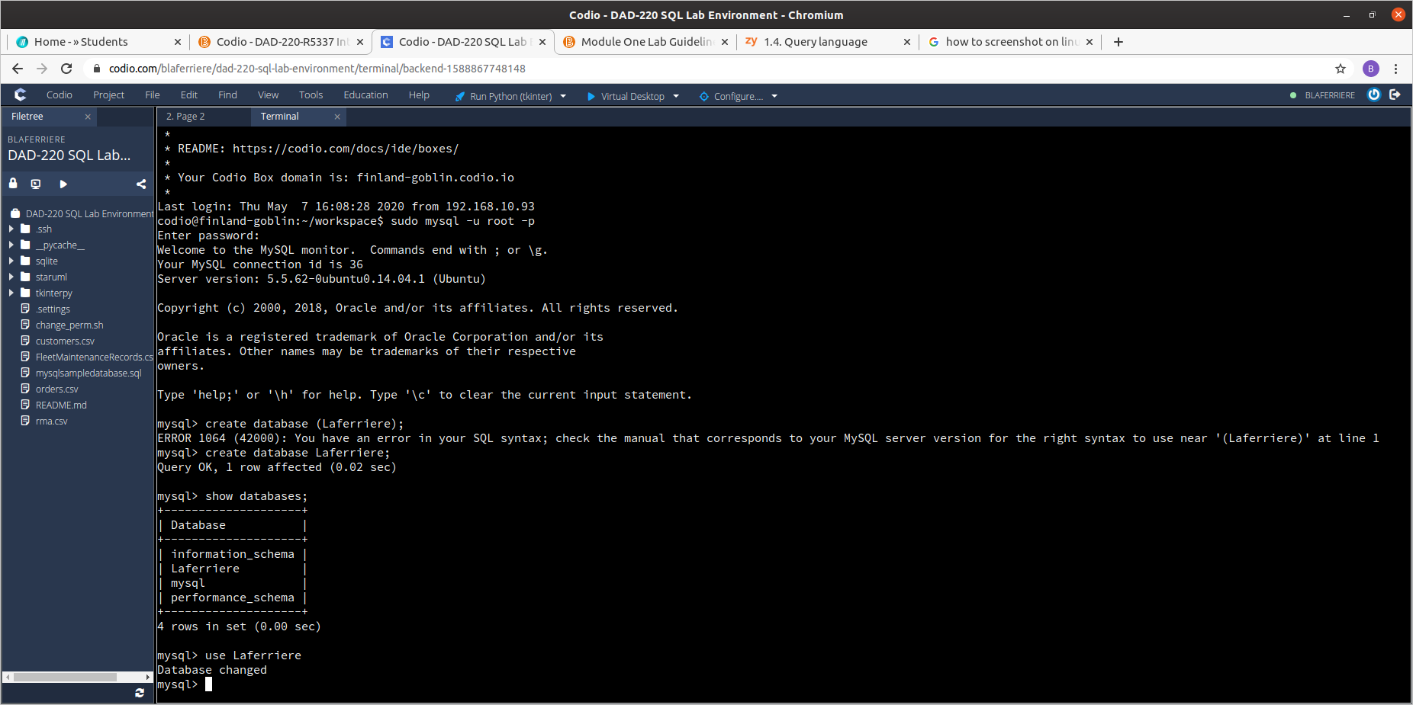
3. Create a table called tb2 and list out the tables in your database by using the following commands:
- create table tb2 (user_id VARCHAR(50));
  - press enter
- show tables;
  - press enter
- describe tables;
  - press enter
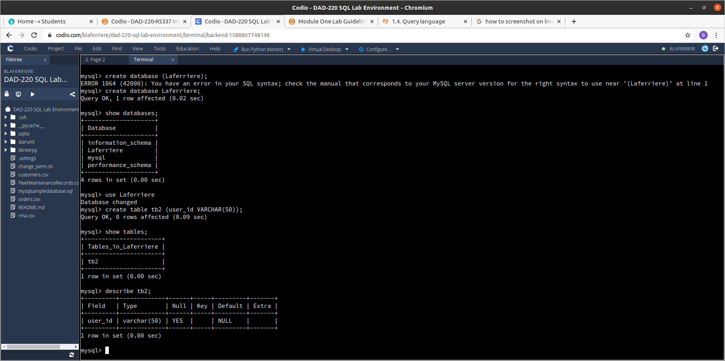

4. Add a second field by entering the following commands:
- alter table tb2 add newfield VARCHAR(25);
  - press enter
- describe tb2;
  - press enter
